Introduction to Programming Language with AI (JavaScript + Node.js)

Q2. Introduction to Node.js
1.What is Node.js?
Node.js is an open-source, cross-platform JavaScript runtime environment that allows JavaScript to run outside a web browser. It is built on Google Chrome's V8 JavaScript Engine and is widely used for developing backend applications, APIs, automation scripts, and testing frameworks.
Node.js allows JavaScript to run outside the browser.
Key Characteristics
- Open Source: Free and community-supported.
- Cross-Platform: Works on Windows, Linux, and macOS.
- Event-Driven: Handles tasks using an event-based architecture.
- Non-Blocking: Performs I/O operations efficiently without unnecessary waiting.
- Asynchronous: Can handle multiple operations efficiently.
- NPM Support: Provides thousands of reusable packages and libraries.
- Scalable: Suitable for applications handling many concurrent operations.

Importance of Node.js for QA
Node.js is important for QA Automation because many modern testing tools are built on its ecosystem, including:
- Playwright – Web and E2E Testing
- Cypress – Web Testing
- WebdriverIO – Browser Automation
- Jest – JavaScript Testing
- Mocha – Test Framework
- Supertest – API Testing
Therefore, JavaScript + Node.js provides a strong foundation for modern QA Automation and test framework development.

2.How does Node.js work?
Node.js follows an event-driven, non-blocking I/O architecture. Instead of creating a separate thread for every request, Node.js uses a single main JavaScript thread together with an Event Loop and asynchronous APIs to efficiently manage many operations.

Basic Working Flow of Node.js
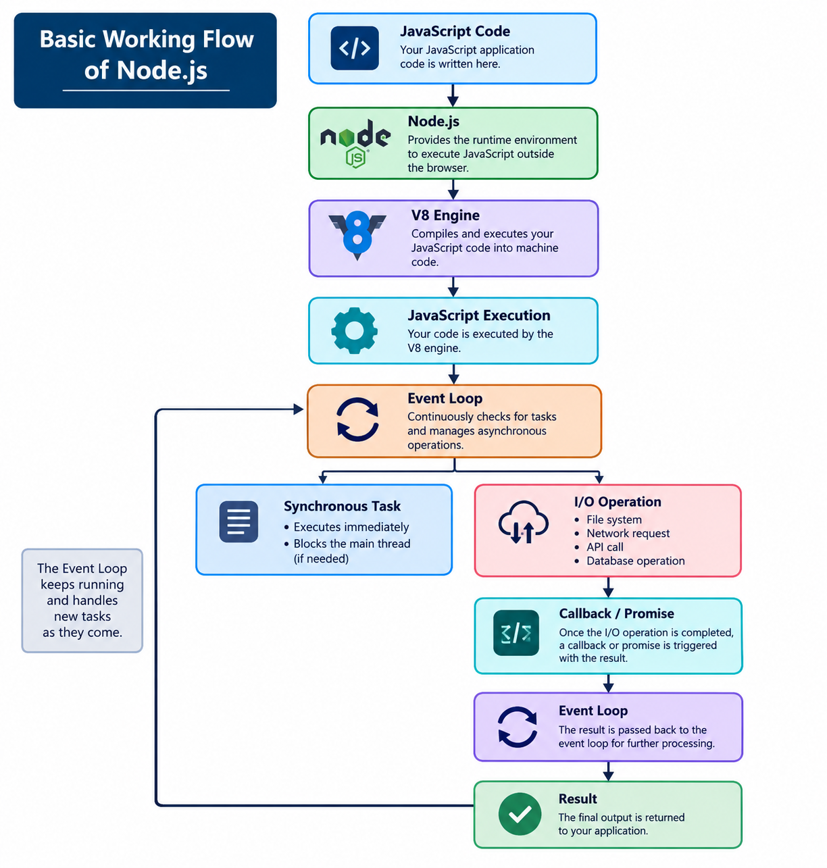
Explanation:
- The developer writes JavaScript/TypeScript code.
- Node.js receives and executes the code.
- The V8 engine executes JavaScript.
- Node.js APIs handle system-level operations.
- The Event Loop manages asynchronous tasks.
- I/O operations are processed without unnecessarily blocking the main thread.
- Once an operation is completed, its result is returned to the application.

Major Components of Node.js
1. V8 JavaScript Engine
- Developed by Google.
- Executes JavaScript code efficiently in Node.js.
2. Event Loop
- Handles asynchronous tasks.
- Allows Node.js to perform multiple operations without blocking the program.
3. Non-Blocking I/O
- Handles file, database, API and network operations without stopping other tasks.
- Improves application performance and efficiency.
4. Asynchronous Programming
- Supports Callbacks, Promises, and async/await.
- Helps manage tasks that take time to complete.
3.Advantages of Node.js for QA Automation
Node.js is widely used in QA Automation because it is fast, flexible, scalable, and supports many modern testing tools.
1. Supports Modern Automation Tools
Node.js supports tools like Playwright, Cypress, Jest, Mocha, WebdriverIO, and Supertest.
Example: npm install playwright
2. Fast Test Execution
Its V8 engine and asynchronous architecture help execute automation tasks efficiently.
Example: A test can send an API request while performing other independent tasks.
3. Rich NPM Ecosystem
NPM provides thousands of ready-to-use testing libraries, reducing development time.
4. Easy Framework Development
Node.js helps create reusable, maintainable, and scalable automation frameworks.
5. API Testing
QA engineers can test status codes, response data, authentication, headers, and errors.
Example: Send API Request → Receive Response → Validate → PASS/FAIL
6. UI & E2E Testing
With tools like Playwright, QA engineers can automate complete user workflows from login to checkout.
7. CI/CD Integration
Automated tests can run automatically whenever new code is pushed.
8. JavaScript & TypeScript Support
Supports both JavaScript and TypeScript, making large automation projects easier to maintain.
9. Cross-Platform Support
Node.js works on Windows, Linux, and macOS.
10. Easy Tool Integration
Node.js can combine UI testing, API testing, test frameworks, and reporting into one automation ecosystem.

Professional QA Automation Diagram
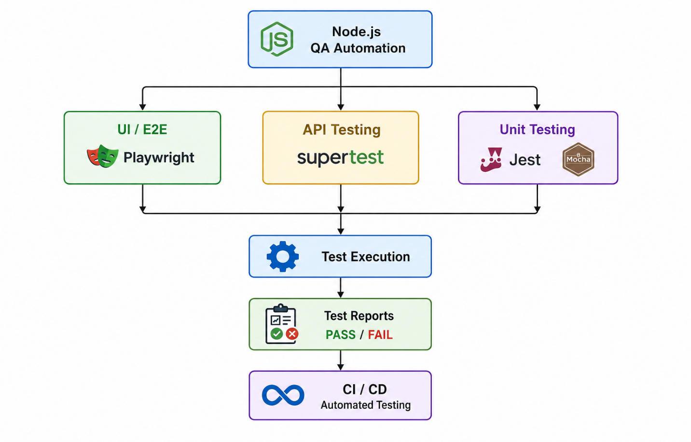

4. Difference between Browser JavaScript and Node.js
Although both use JavaScript, Browser JavaScript and Node.js run in different environments and provide different capabilities.
Browser JavaScript vs. Node.js
Feature | Browser JavaScript | Node.js
Execution Environment | Web Browser | Operating System / Server
Primary Purpose | Web page interaction and frontend functionality | Backend development, automation, and developer tools
DOM Access | Yes | No built-in DOM
window Object | Available | Not available by default
document Object | Available | Not available by default
File System Access | Highly restricted for security | Supported through built-in modules
NPM Packages | Not directly available like Node.js | Fully supported through npm
HTTP Server | Not normally used to create servers | Can create and run HTTP servers
Database Connectivity | Usually through backend APIs | Can use database drivers directly
Environment Variables | Limited | Fully supported
OS-Level Access | Restricted for security | More extensive access
Common Usage | Frontend / UI development | Backend / Automation / Tooling
Testing Usage | Browser-based and UI testing | Test automation, API testing, and backend testing
Example API | document.querySelector() | fs.readFile()
Note: Browser JavaScript primarily runs inside the browser sandbox, while Node.js provides a server-side JavaScript runtime with broader system and development capabilities.

